**Phase-Structure Grammar**

1. What is the Backus-Naur form of the grammar described as follows:
2. a **sentence** is made up of a **noun phrase** followed by a **verb phrase** or a **noun phrase** followed by a **verb phrase** followed by a **noun phrase**.
3. a **noun phrase** is made up of a **noun**, an **adjective** followed by a **noun**, or an **article** followed by a **noun**.
4. a **verb phrase** is made up of a **verb**.
5. **articles** are *a* and *the*.
6. **adjectives** are *lengthy*, *boring*, and *inaccurate*.
7. **nouns** are *book*, *newspaper*, and *information*.
8. **verbs** are *reads* and *contains*.
   1. the Backus-Naur form

|  |
| --- |
| 1. **〈**sentence**〉** ::= **〈**noun phrase**〉** **〈**verb phrase**〉** |**〈**noun phrase**〉** **〈**verb phrase**〉 〈**noun phrase**〉**  2. **〈**noun phrase**〉** ::= **〈**noun**〉 〈**adjective**〉 〈**noun**〉** | **〈**article**〉 〈**noun**〉**  3.**〈**verb phrase**〉** ::= **〈**verb**〉**  4. **〈**article**〉** ::= a|the  5. **〈**adjective**〉** ::= lengthy| boring | inaccurate.  6. **〈**nouns**〉** ::= book | newspaper | information.  7. **〈**verbs**〉** ::= *reads* | *contains.* |

b. Demonstrate “a lengthy book contains boring information”

a lengthy book contains |boring information

**〈**article**〉 〈**noun phrase**〉 〈**verb phrase**〉 〈**noun phrase**〉**

**〈**article**〉 〈**adjective**〉 〈**noun**〉**  **〈**verbs**〉 〈**adjective**〉 〈**noun**〉**

1. Give the Backus-Naur form for the production of signed integers in decimal notation.(A signed integer is a nonnegative integer preceded by a plus sign or a minus sign, E.g. -5, 10, -10050)

Sol.

〈signed integer〉 ::= 〈sign〉 〈integer〉

〈sign 〉 ::= + | -

〈integer 〉 ::= 〈digit〉 |〈digit〉 〈integer〉

〈digit〉 ::= 0 | 1 | ⋯ | 8 | 9

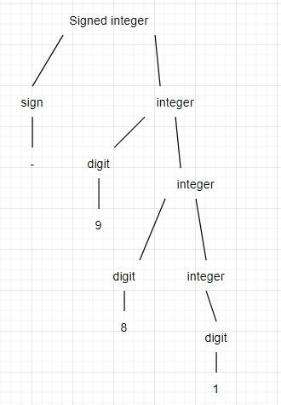Construct a derivation tree for −981 using the grammar

1. Let G be the grammar with V = {p,q,r,s,}; T = {p,q,r}; Starting symbol S; and

productions are: S → pSr, S → rqS, S →rr, S →pqr

* 1. Construct derivation tree for rqppqrr

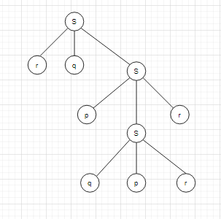

1. Use top-down parsing to determine whether each of the following strings belongs to the language generated by the grammar.

a) prrr Yes

b) rqpqr Yes

c) pqrpqr No

d) prrrr No

**Finite State Machines with no output**

1. **Construct the state table** for the finite-state machine with the state diagram shown in figure

a/1

a/0

b/0

b/0

Start

|  |  |  |  |  |
| --- | --- | --- | --- | --- |
| State | f | | g | |
| Input | | Input | |
| a | b | a | b |
| S0  S1 | S0  S1 | S1  S1 | 1  0 | 0  0 |

* **Find the output string** generated by the finite-state machine in figure and show the successive states and outputs in Table

1. input string is ababbb

|  |  |  |  |  |  |  |  |
| --- | --- | --- | --- | --- | --- | --- | --- |
| Input | a | b | a | b | b | b | - |
| State | S0 | S0 | S1 | S1 | S1 | S1 | S1 |
| Output | 1 | 0 | 0 | 0 | 0 | 0 | - |

1. input string is aaabb

|  |  |  |  |  |  |  |
| --- | --- | --- | --- | --- | --- | --- |
| Input | a | a | a | b | b | - |
| State | S0 | S0 | S0 | S1 | S1 | S1 |
| Output | 1 | 1 | 1 | 0 | 0 | - |

1. input string is baaaa

|  |  |  |  |  |  |  |
| --- | --- | --- | --- | --- | --- | --- |
| Input | b | a | a | a | a | - |
| State | S0 | S1 | S1 | S1 | S1 | S1 |
| Output | 0 | 0 | 0 | 0 | 0 | - |

1. **Construct the** state diagram for the finite-state machine with state table

|  |  |  |  |  |  |  |  |  |  |  |  |  |  |  |  |  |  |  |  |  |  |  |  |  |  |  |  |  |  |
| --- | --- | --- | --- | --- | --- | --- | --- | --- | --- | --- | --- | --- | --- | --- | --- | --- | --- | --- | --- | --- | --- | --- | --- | --- | --- | --- | --- | --- | --- |
|  | |  |  |  |  |  | | --- | --- | --- | --- | --- | | State | f | | g | | | Input | | Input | | | a | b | a | b | | S0 | S1 | S2 | 0 | 0 | | S1 | S1 | S2 | 0 | 1 | | S2 | S1 | S2 | 1 | 0 | |

* **Find the output string** generated by the finite-state machine in figure and show the successive states and outputs in Table

1. input string is abaabaa

|  |  |  |  |  |  |  |  |  |
| --- | --- | --- | --- | --- | --- | --- | --- | --- |
| Input | a | b | a | a | b | a | a | - |
| State | S0 | S1 | S2 | S1 | S1 | S2 | S1 | S1 |
| Output | 0 | 1 | 1 | 0 | 1 | 1 | 0 | - |

1. input string is babbbab

|  |  |  |  |  |  |  |  |  |
| --- | --- | --- | --- | --- | --- | --- | --- | --- |
| Input | b | a | b | b | b | a | b | - |
| State | S0 | S2 | S1 | S2 | S2 | S2 | S1 | S2 |
| Output | 0 | 1 | 1 | 0 | 0 | 1 | 1 | - |

**Set of Strings**

1. Let A={0,11} and B = {00,01}. Find each of these sets.
2. AB = { 000, 001, 1100, 1101 }
3. BA = { 000, 0011, 010, 0111 }
4. A2 = { 00, 011, 110, 1111 }
5. B3 = { 000000, 000001, 000101, 010100, 010000, 000100, 010101 }
6. A UB = { 010001 }
7. Determine whether the string 0101000 is in each of these sets.
   1. {101}* No
   2. {01}*{0}* Yes
   3. {0}*{10}*{0}* Yes
   4. {0}*{1}*{0}* No

**DFA Automata**

1. A finite-state automaton is given by a transition diagram

|  |  |
| --- | --- |
|  | 1. Find its states   σ0, σ1, σ2, σ3   1. Fins its input symbols   a, b   1. Find its initial state   σ0   1. Find its accepting states   σ3 |

e) Do the input string below accept or not (Yes/No)

aaaaabba No

abbbaabbb No

babbaaaba Yes

baaabaaba Yes

f) Write its annotated next-state table

|  |  |  |
| --- | --- | --- |
| State | f | |
| Input | |
| a | b |
| σ0 | σ1 | σ0 |
| σ1 | σ1 | σ2 |
| σ2 | σ3 | σ0 |
| σ3 | σ1 | σ2 |

1. A finite-state automaton is given by an annotated next-state table. For each automaton

|  |  |  |  |  |
| --- | --- | --- | --- | --- |
| State | f | |  | 1. Find its states   s0, s1, s2, s3   1. Find its input symbols   f   1. Find its initial state   s0   1. Find its accepting states   s3 |
| input | |  |
| a | b |  |
| s0  s1  s2  🞇  S3 | S1  S1  S1  S1 | S0  S2  S3  S0 |  |

e) Do the input string below accept or not (Yes/No)

aabbabba No

abbbaabb Yes

babbaaaa No

baaabaabba No

f) Draw its transition diagram

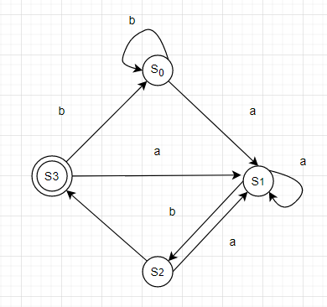

**Language Recognition**

1. Determine the set of bit strings recognized by the following deterministic finite-state automaton.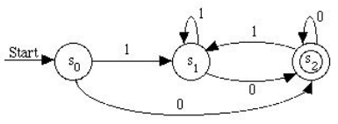

|  |
| --- |
| If the bit string end in 0 ,you end in state S2. If the bit string ends in 1, you end in state S1. Therefore, this automaton recognizes all bit strings that end in 0. |

1. **Determine whether 01010001** belongs to each of these regular sets.

a) 01*0* No

b) 0(11)*(01)* No

c) 0(10)*0*1* Yes

d) 0*10(0 ∪ 1)* No

e) (01)*(11)* No

f ) 0*(10 ∪ 11)*0*1 Yes

g) 0*(10)*11 No

h) 01(01 ∪ 0)1* No

12. Construct a deterministic finite-state automaton that recognizes the set of all bit strings such that **the first bit is 0 and all remaining bits are 1’s.**

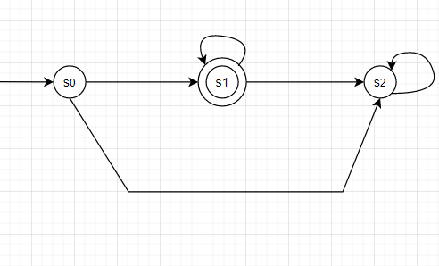

**Turing Machines**

1. Let T be the Turing machine defined by these five-tuples:

(s0, 0, s1, 1, R), (s0, 1, s0, 0, R), (s0,B, s1, 0, R), (s1, 0, s0, 0, R), (s1, 1, s2, 0, R), (s1,B, s2, 1, L).

If T is run on the following tape, beginning in initial position, what is the final tape when T halts?

**S0**



S1



1

S2

|  |  |  |  |  |  |  |  |  |  |  |
| --- | --- | --- | --- | --- | --- | --- | --- | --- | --- | --- |
| **…** | **B** | **B** | **1** | **0** | **B** | **1** | **1** | **B** | **B** | **…** |

1. Let T be the Turing machine defined by these five-tuples:

(s0, 0, s1, 1, R), (s0, 1, s0, 0, R), (s0, B, s1, 0, R), (s1, 0, s0, 0, R), (s1, 1, s2, 0, R), (s1, B, s2, 1, L).

If T is run on the following tape, beginning in initial position, what is the final tape when T halts?

**S0**



S0

|  |  |  |  |  |  |  |  |  |  |  |
| --- | --- | --- | --- | --- | --- | --- | --- | --- | --- | --- |
| **…** | **B** | **B** | **0** | **B** | **0** | **1** | **0** | **B** | **B** | **…** |

S1

|  |  |  |  |  |  |  |  |  |  |  |
| --- | --- | --- | --- | --- | --- | --- | --- | --- | --- | --- |
| **…** | **B** | **B** | **0** | **0** | **0** | **1** | **0** | **B** | **B** | **…** |

S0

|  |  |  |  |  |  |  |  |  |  |  |
| --- | --- | --- | --- | --- | --- | --- | --- | --- | --- | --- |
| **…** | **B** | **B** | **0** | **B** | **0** | **1** | **0** | **B** | **B** | **…** |

S0

|  |  |  |  |  |  |  |  |  |  |  |
| --- | --- | --- | --- | --- | --- | --- | --- | --- | --- | --- |
| **…** | **B** | **B** | **0** | **0** | **0** | **0** | **0** | **B** | **B** | **…** |

S1

|  |  |  |  |  |  |  |  |  |  |  |
| --- | --- | --- | --- | --- | --- | --- | --- | --- | --- | --- |
| **…** | **B** | **B** | **0** | **0** | **0** | **0** | **1** | **1** | **B** | **…** |

S2

|  |  |  |  |  |  |  |  |  |  |  |
| --- | --- | --- | --- | --- | --- | --- | --- | --- | --- | --- |
| **…** | **B** | **B** | **0** | **0** | **0** | **0** | **1** | **0** | **B** | **…** |